**Knowledge Discovery Management Project**

**Increment-IV Report**

**Social Trend Analysis**



**Team:**

**Ashok Rudraraju,**

**Aditya Deshpande,**

**Tej Kiran Meka,**

**Mahesh Vemula.**

**Tasks Completed:**

1. Used Geocoding service to convert location to latitude/longitude and store it in Solr
2. Retrieved Data from Solr as Restful web service.
3. Used google maps to plot the locations(Visualization of data from Solr)
4. Used google charts api to compare usage of various operating systems(Visualization of data from Solr)

**Used google Geocoding service to convert location to latitude/longitude and store it in Solr:**

We have implemented Geocoding api in python using python lib (pygeocoder) to convert location (i.e. country name) to latitude/longitude.

*Python script:*

*import pygeocoder*

*f = open(r'C:\Users\Nandu\phython\data_out.txt')*

*file_name2 = 'C:\Users\Nandu\phython\out_duplicate.txt'*

*f2=open(file_name2,'w')*

*for line in f:*

*city = '' "*

*a = True*

*i = 8*

*x = line[i]*

*while a:*

*city += x*

*i += 1*

*x = line[i]*

*if (x == '/' )| (x=='"'):*

*a = False*

*r = Geocoder.geocode(city)*

*y = line[-1:3]+",\"lat\"""+str(r[0].coordinates[0])+"\",\"long\"""+ str(r[0].coordinates[1])+"\"}]\n" f2.write(y)*

Added lat and long keys to existing JSON and pushed updated JSON into Solr

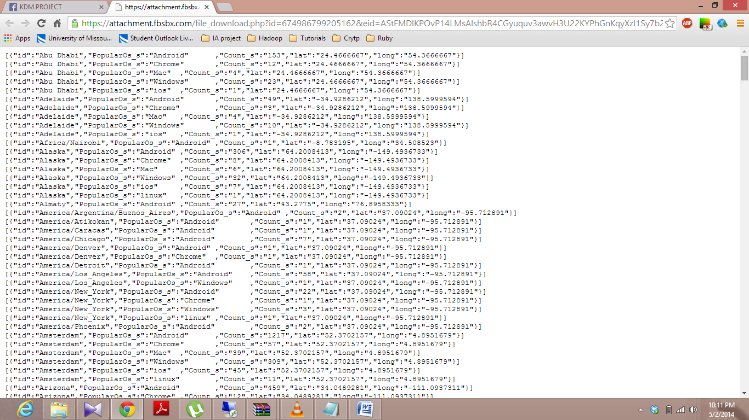

**Retrieved Data from Solr as Restful web service:**

Fetched data from Solr in form of Rest web service.

*Web service:*

[http://134.193.136.127:8983/solr/collection1_shard1_replica1/select?q=id%3AMumbai&wt=json&indent=true](http://www.facebook.com/l.php?u=http%3A%2F%2F134.193.136.127%3A8983%2Fsolr%2Fcollection1_shard1_replica1%2Fselect%3Fq%3Did%253AMumbai%26wt%3Djson%26indent%3Dtrue&h=hAQGBHC2e)

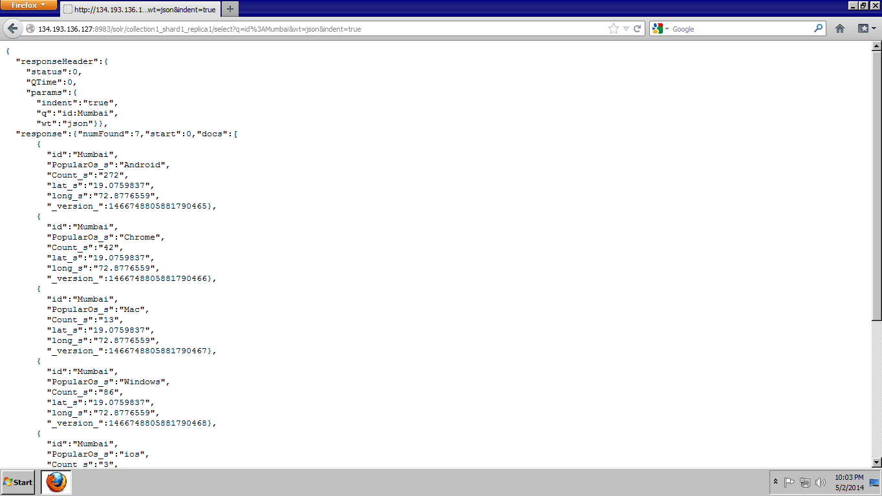

**Used google maps to plot the locations(Visualization of data from Solr):**

Used Google Maps api to display maps on the webpage. Added marker to plot locations.

API: <https://maps.googleapis.com/maps/api/js?v=3.exp&sensor=false>

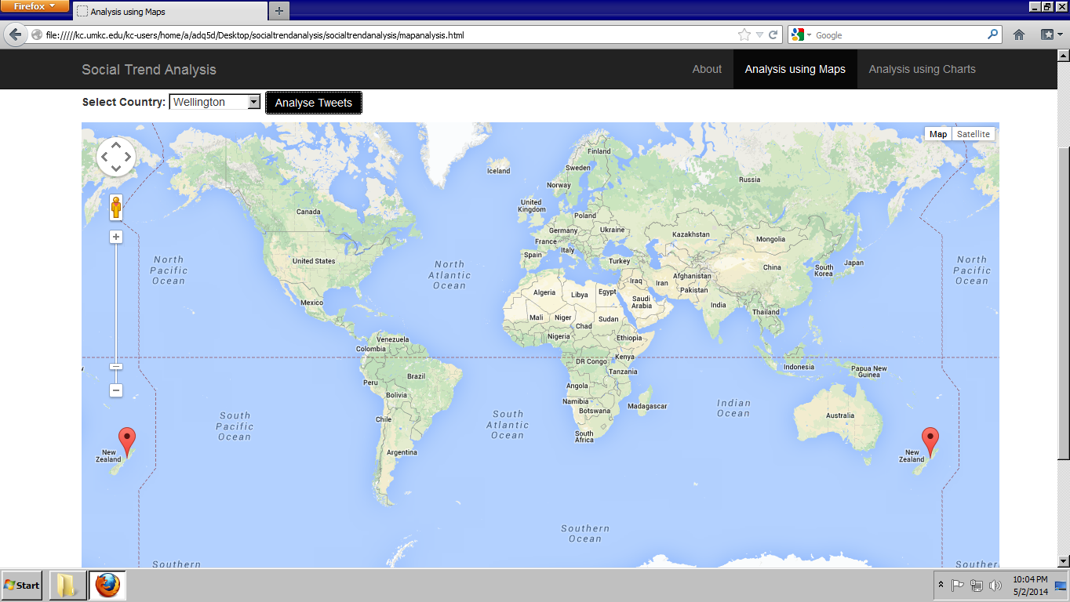

**Used am charts api to compare usage of various operating systems(Visualization of data from Solr):**

Script:

<script type="text/javascript" src="http://www.amcharts.com/lib/3/amcharts.js"></script>

<script type="text/javascript" src="http://www.amcharts.com/lib/3/pie.js"></script>

<script type="text/javascript" src="http://www.amcharts.com/lib/3/themes/none.js"></script>

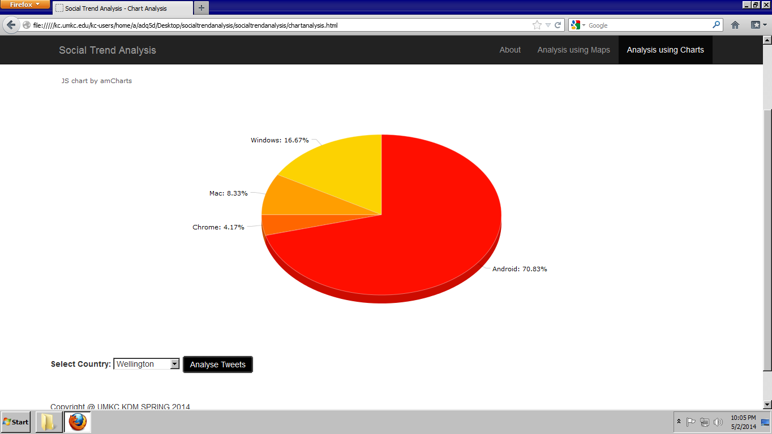

**YouTube URL:**

http://www.youtube.com/watch?v=ZVVpgND0Wvs

**Issues:**

Call solr web service in the website through Ajax script.

Scrumdo of our project is not working due to more number of project members.

**Github URL:**